**GROCERY RECOMMENDATION SYSTEM FOR RETAIL MARKETS**

1. **INTRODUCTION**

In grocery stores, large-scale transaction data with identifification, such as point of sales (POS) data, is being accumulated as a result of the introduction of frequent shopper programs (FSPs). The accumulated POS data have been used to examine customer shopping behavior, especially by professionals in the marketing fifield1, 2. Although the recommendations based on this data are often adopted in e-commerce shopping stores 3, they are rarely introduced in face-to-face selling, such as in brick-and-mortar grocery stores. Therefore, introducing a system

based on these recommendations to grocery stores could induce customers to visit the store to make a purchase. We propose two recommended systems based on stored POS data, and these are shown in Figure 1. The first system gathers the e-mail address during the registration procedure and directly determines recommended products based on the stored POS data and sends reminders with discount information to customers by e-mail . When constructing this system for grocery stores, the sparsity of evaluation values presents a problem. Evaluation values are constructed based on customers’ purchase frequency of product items and is very sparse. This is because individual customers only purchase very few of the total number of product items a store sells.

**1.1 OVERVIEW**

Modern supermarkets use loyalty schemes (e.g., loyalty cards) to reward repeated customers on purchases.In this work,we suggest an interactive rewarding scheme guided by a dynamic,real-time recommendation engine.More specifically,we propose the replacement of loyalty cards

with an interactivesmart-device application, which acts both as a bonuscard and as a recommendation engine. This section presents an overview of the proposed methodology

**1.2 PURPOSE**

Hello,Grocery Recommendation System,for Retail Markets this guided project focuses on building a system where cameras at entry recognize the customer and link his previous purchase history stored in the database.Based on that purchase history he will get a recommendation of the offers on the product which he wishes to buy.And also displays on the screen at the entrance as soon as he steps into the store

**2.LITERATURE SURVEY**

**2.1 EXISTING PROBLEM**

      Here the main concepts of hybrid recommendation techniques have been extracted. It mainly describes combining the advantages of algorithms to form into one useful and effective algorithms which gives an edge over its base algorithms .It helps to incorporate the information from metadata into recommendation algorithms. Content based inputs have been used from this paper. Content based generally consists the information about the user such as their

interests, name, address, age etc. This helps a lot to improve the recommendation engine.

**2.2 PROPOSED SOLUTION**

    Here the main concepts of hybrid recommendation techniques have been extracted. It mainly describes combining the advantages of algorithms to form into one useful and effective algorithms which gives an edge over its base algorithms .It helps to incorporate the information from metadata into recommendation algorithms. Content based inputs have been used from this paper. Content based generally consists the information about the user such as their

interests, name, address, age etc. This helps a lot to improve the recommendation engine.

**3.THEORITICAL ANALYSIS**

**3.1 BLOCK DIAGRAM**

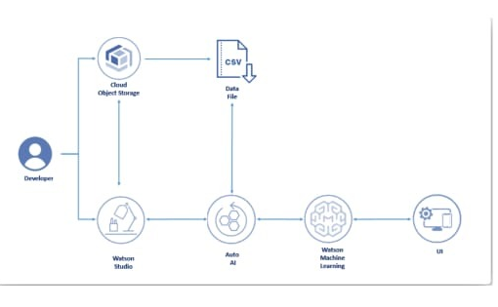

**3.2 HARDWARE/SOFTWARE SOLUTION**

**PROJECT REQUIREMENTS**

1. A Classification algorithm with maximum accuracy to be  trained and tested on the dataset.
2. The Dataset consists of 8 columns excluding the predicting column i.e. Class

**SOFTWARE REQUIREMENTS**

1. IBM Cloud
2. IBM Watson Studio
3. Node-red App

**4.EXPERIMENTAL INVESTIGATION**

**1.Choose a Project Idea:**

Predicting Diabetic Mellitus of a person using AutoAI.

**2 .Conduct Background Research:**

 https://github.com/Grocery

**3.Compose a Hypothesis:**

Based on our study and information gathered we can predict whether  a person has diabetes or not.

**4.Design your Experiment:**

First, we need to collect the suitable dataset for our problem statement. Next, we need to run the AutoAI experiment for this problem and use the algorithm which has the highest accuracy.

**5.Draw Conclusions:**

After building our model, we can predict the class of a person(i.e.0 ).

**5.FLOWCHART**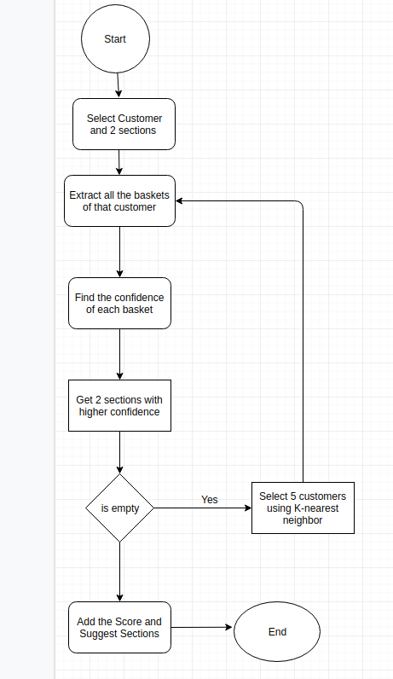

1. **RESULT**

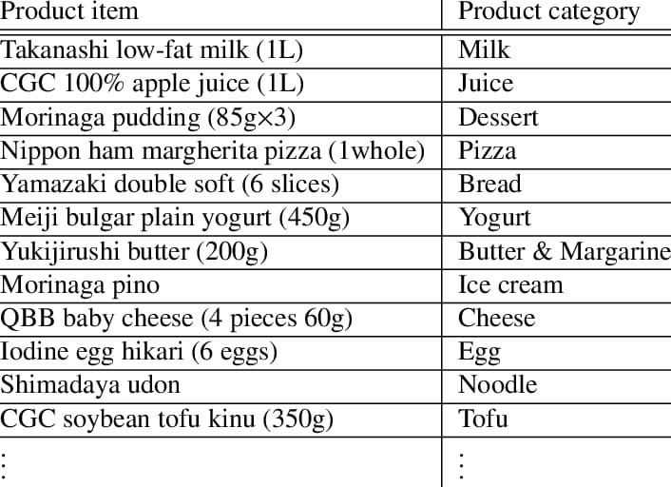

**7.ADVANTAGES AND DISADVANTAGES**

**ADVANTAGES**

Easy to access the system anywhere and anytime.

Increasing customer loyalty with interesting offers.

Growth of purchase and therefore business profit.

Opportunity to meet customers and understand their needs better.

Broadening customer minds due to offering items that are relevent to their shopping basket.

**DISADVANTAGES**

**Deterministic problems:**This method is not very efficient for deterministic problems.

**Lack of good data**:it may leads to problems.

Interpretability

**8.APPLICATIONS**

This system can be used by the multiple peoples to get the counselling sessions online.

**9.CONCLUSION**

          Well, this recommendation system result is appreciable as it guessed 70% of sections in the basket. This can be further optimized by understanding and analyzing more about section recommendations.

1. **FUTURE SCOPE**

Therefore, proposing a method to analyze the customers’ need plays an important role in attracting new and regular customers. The purpose of this study is to formulate a product recommendation system which analyze customers’ needs and thus recommend the best products.

**11.BIBILOGRAPHY**

https://www.researchgate.net/publication/350156753_Online_Grocery_Recommendation_System

**12.APPENDIX**

Node-RED Flow Output

**UI OUTPUT SCREENSHOT**

